

American International University-Bangladesh

(AIUB)

Department of Computer Science and Engineering (CSE)

Faculty of Science & Technology (FST)

Spring 2022-23

Course: Introduction to Data Science

Section: B

Final Term Project

**Submitted by:**

**Name: Sakib-Ul-Ahsan**

**ID: 20-42978-1**

**Department: CSE**

**Submitted to:**

**Tohedul Islam**

**Assistant Professor**

**Department of Computer Science**

**Dataset Description**: The dataset was collected from Kaggle. The name of the dataset is loan_approval_dataset. It was collected in csv format. It contains 13 attributes and 4269 instances. The attributes include loan_id, no_of_dependents, education, self_employed, loan_amount, loan_term, cibil_score, residential_assets_value, commercial_assets_value, luxury_assets_value, bank_asset_value, loan_status. The target attribute is named loan_status. Which has only two values approved or rejected.

**Importing the dataset:**

mydata <- read.csv("C:/Users/USER/Desktop/Data Science/Final project/loan_approval_dataset.CSV", header = TRUE, sep = ",")

mydata

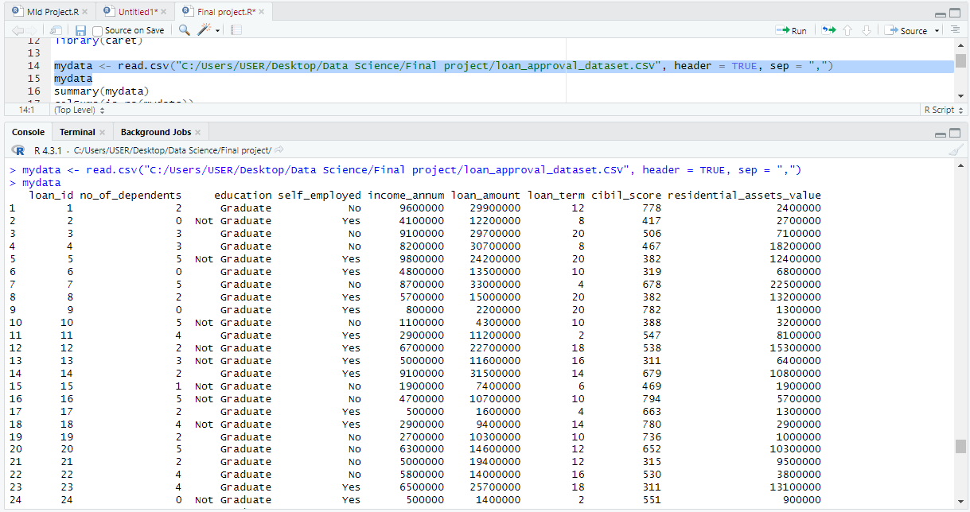

**Summary of all the attributes:**

summary(mydata)

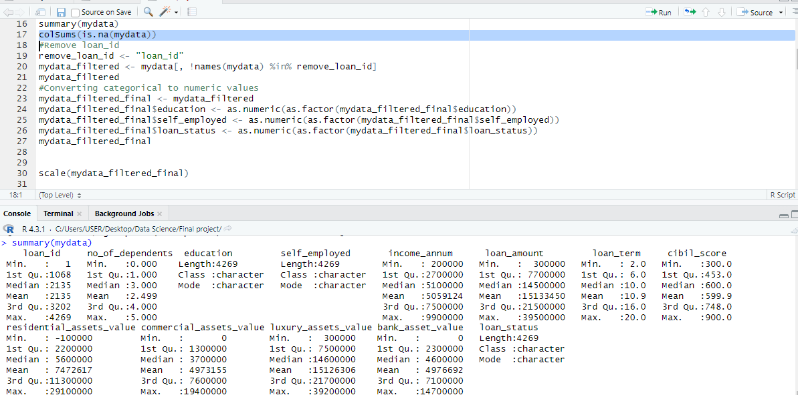

**Look for missing values:**

colSums(is.na(mydata))

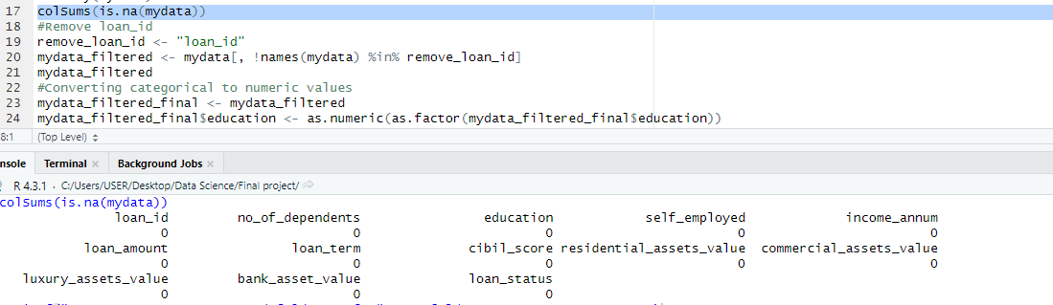

**Data Pre-processing:**

**Removing loan_id attribute:**

remove_loan_id <- "loan_id"

mydata_filtered <- mydata[, !names(mydata) %in% remove_loan_id]

mydata_filtered

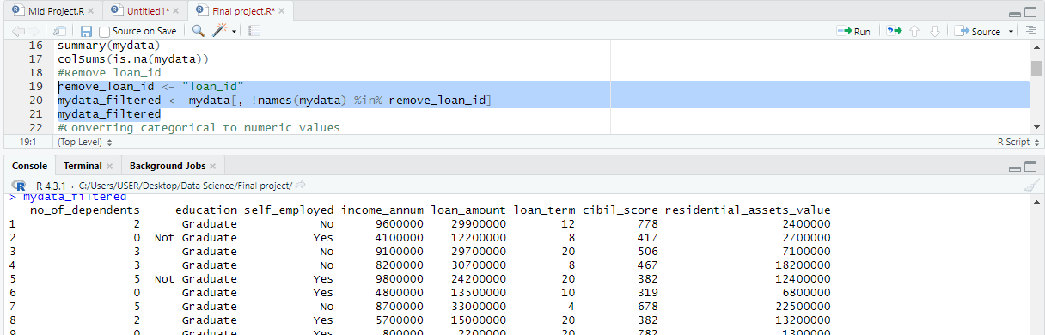

**Converting categorical values to numeric values:**

mydata_filtered_final <- mydata_filtered

mydata_filtered_final$education <- as.numeric(as.factor(mydata_filtered_final$education))

mydata_filtered_final$self_employed <- as.numeric(as.factor(mydata_filtered_final$self_employed))

mydata_filtered_final$loan_status <- as.numeric(as.factor(mydata_filtered_final$loan_status))

mydata_filtered_final

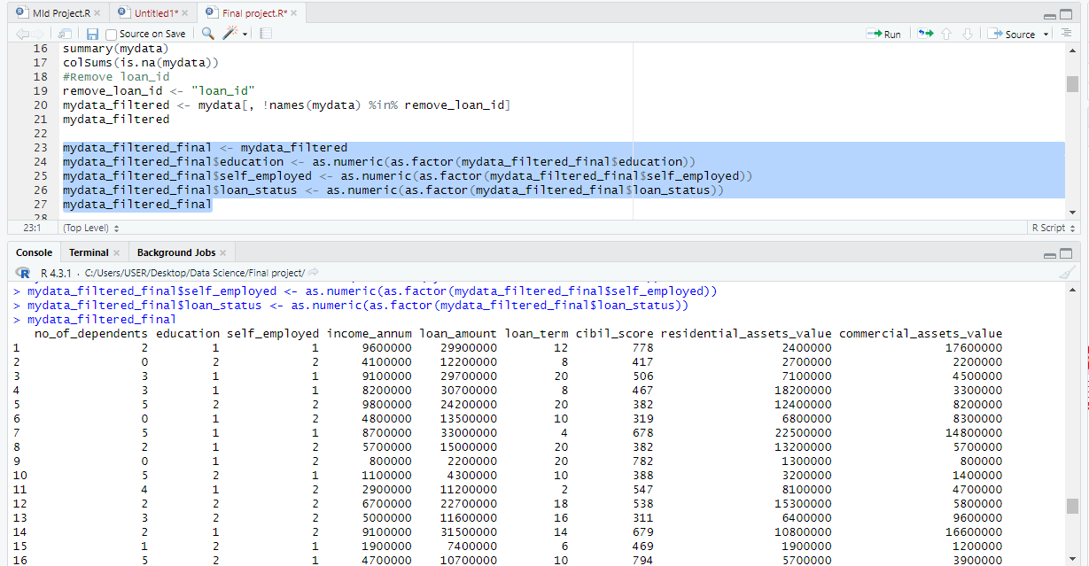

**Scalling:**

scale(mydata_filtered_final)

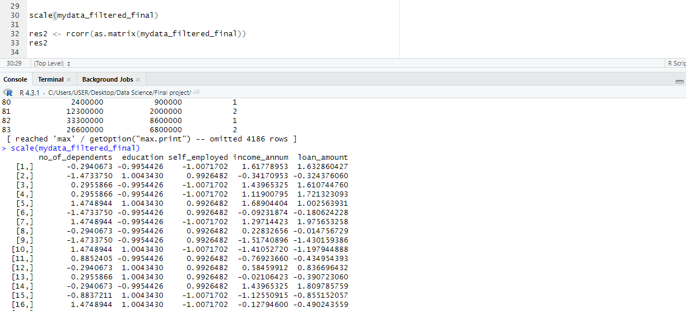

**Correlation Matrix:**

res2 <- rcorr(as.matrix(mydata_filtered_final))

res2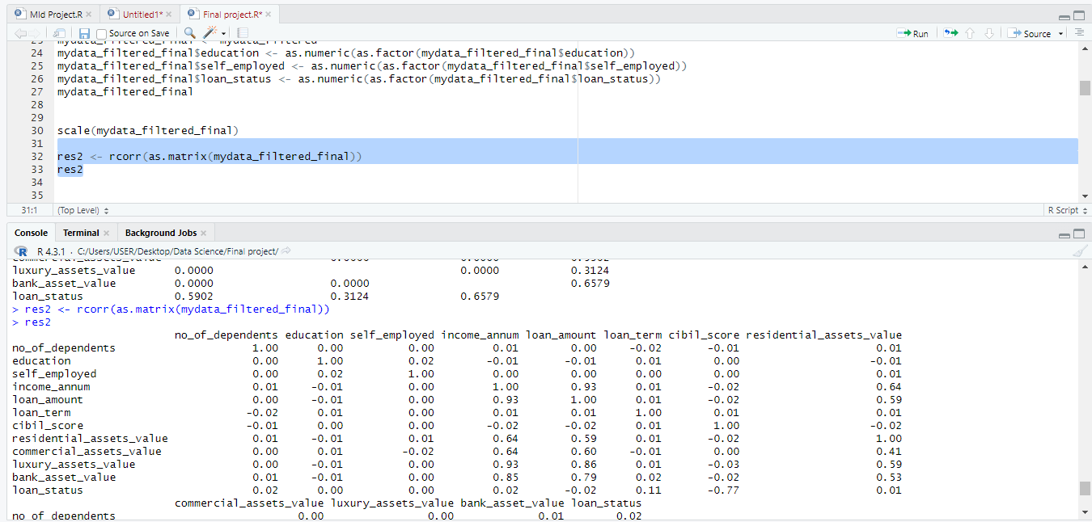

**Correlation Matrix with figure:**

correlation_matrix <- cor(mydata_filtered_final[, sapply(mydata_filtered_final, is.numeric)])

corrplot(correlation_matrix, method = "color")

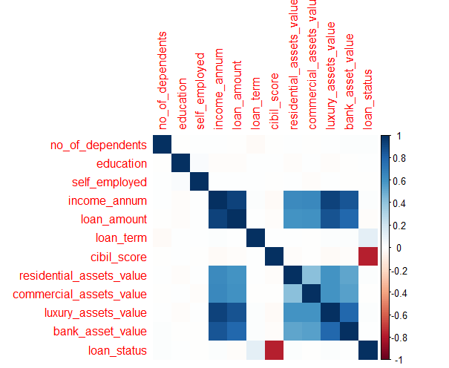

**Splitting the data into 80/20 train/test ratio:**

set.seed(255)

split <- sample.split(mydata_filtered_final$loan_status, SplitRatio = 0.8)

train <- subset(mydata_filtered_final, split == TRUE)

test <- subset(mydata_filtered_final, split == FALSE)

train_scaled <- scale(train[, -13])

test_scaled <- scale(test[, -13])

**Applying the KNN with the value of K as 10:**

k_value <- 10

fold_pred <- knn(

train = train_scaled,

test = test_scaled,

cl = train$loan_status,

k = k_value

)

**Printing the accuracy achieved in KNN and also the required confusion matrix:**

cm <- confusionMatrix(data=fold_pred, reference=as.factor(fold_val$loan_status))

accuracy <- sum(diag(cm)) / sum(cm)

sprintf("Accuracy: %.2f%%", accuracy * 100)

print(cm)

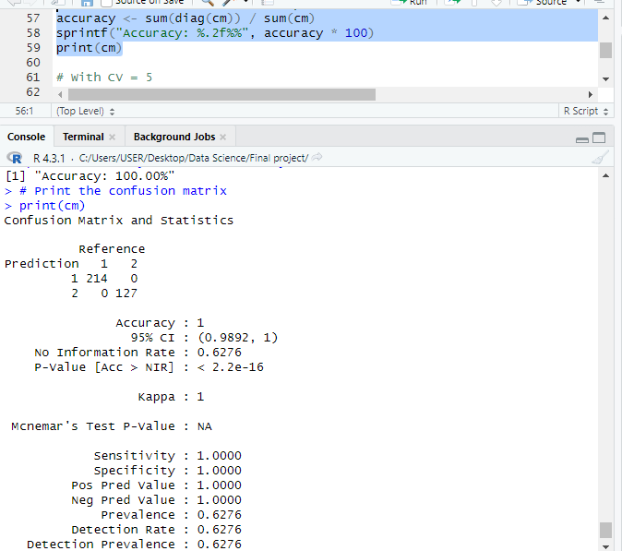

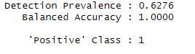

**Applying KNN with cross validation of 10 and finding the accuracy and confusion matrix:**

num_folds <- 10

fold_accuracies <- numeric(length = num_folds

for (fold in 1:num_folds) {

fold_indices <- sample(1:nrow(train), size = floor(1 / num_folds * nrow(train)))

fold_train <- train[-fold_indices, ]

fold_val <- train[fold_indices, ]

fold_train_scaled <- scale(fold_train[, -13])

fold_val_scaled <- scale(fold_val[, -13])

fold_pred <- knn(

train = fold_train_scaled,

test = fold_val_scaled,

cl = fold_train$loan_status,

k = k_value

)

cm_with_cv <- confusionMatrix(data=fold_pred, reference=as.factor(fold_val$loan_status)

print(cm_with_cv)

fold_accuracy <- sum(diag(cm)) / sum(cm)

fold_accuracies[fold] <- fold_accuracy

}

average_accuracy <- mean(fold_accuracies)

sprintf("Average Accuracy across %d folds: %.2f%%", num_folds, average_accuracy * 100)

cm_with_cv

